**Admin Panel**

Student Admission Admitting new students to the school can be done from ‘admit student’

submenu under ‘student’ in the navigation. For adding a student, admin will need to fill up the information required and provided by the admission form. It should be kept in mind that, admitting new student will automatically create an enrollment in the running session for the selected class. Check and recheck the information you have inserted while adding student because once you admit him/her to a class, you will not be able to change his/her class without promoting him/her to the next session.

Bulk Student Admission For admitting bulk students (adding multiple students at a time) you will need to go to the ‘admit bulk student’ submenu under the menu ‘student’. Firstly, select class and section and then fill up the information for each student you want to admit. Make sure to put at least name, email and password for each student you want to admit. You can add rows for adding more as much as you need.

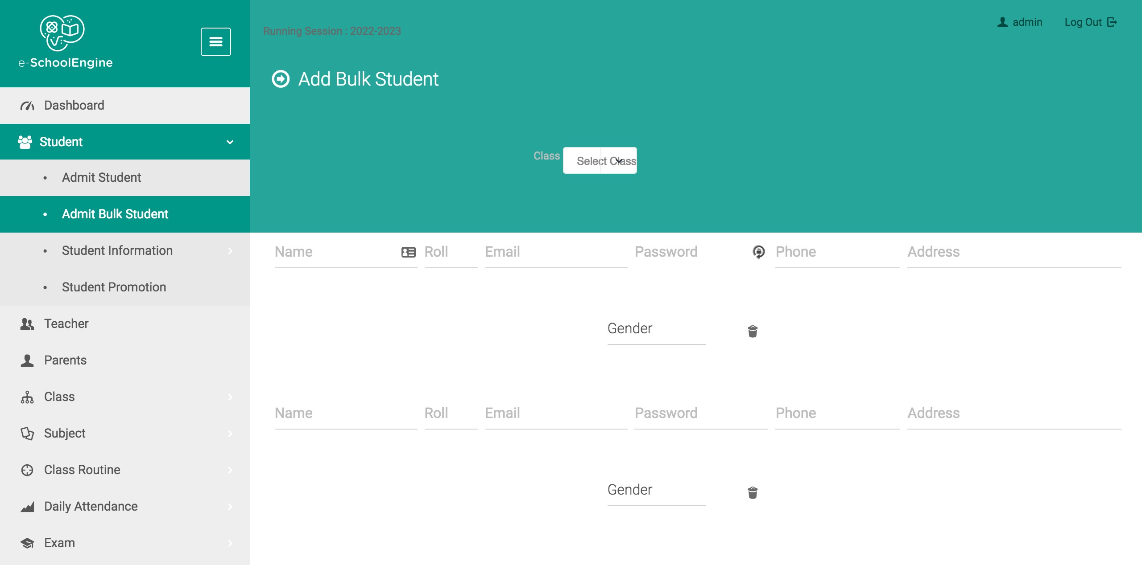

Student Information Student information are shown class wise under the same menu

‘student’. From the page you can get section wise student’s information, his/her profile info, mark sheet. You can also edit student’s basic information form the action button associated with each student.

Student Promotion This module is designed to promote students of a particular class to the next class in the next session. ‘Student Promotion’ submenu will be found under the menu ‘student’ in the admin panel. To promote students to the next class, admin needs to select the present class of the students and the class where he/she wants to promote the students. The present session which has been already set from the system settings will be selected automatically as the present session and the next session will be automatically calculated by the software.

For example, if admin selects to promote students of class three to class four in the next session, there he/she will have two options in a dropdown. One, enroll to class four and two, enroll to class three. Enroll to class four means that the student is qualified to be promoted to class four in the next session. If admin selects enrolling him to class three again then that student will remain in class three in the next session.

**Managing Teachers and Parents From the ‘Teacher’ menu**

admin can create, edit and delete teacher and similarly from ‘Parent’ menu admin can do the same for parents. On creation of either teacher or parent an email is sent to the respective person containing the email and password of the newly created account which later on they can change. Make sure to configure your server SMTP settings for the proper sending of the emails.

Managing Classes and Sections From the menu ‘class’ admin can get access to the submenus named ‘manage classes’ and ‘manage sections’. Admin can create, edit and delete classes and also can do the same with sections. When a class is created, a section along with the class is created by default.

**Academic Syllabus ‘Academic syllabus’** submenu can be accessed from ‘Class’ menu. This module will help admin and also teacher to upload academic syllabus for a particular class. The students of that class will be able to download the syllabus anytime they want. Within a particular session, multiple files can be uploaded under a same class.

**Managing Subjects From the ‘subject’ menu** admin can see subjects class wise for the selected session. As the whole system is session oriented so admin will have the privilege to add different subject for different sessions. For example, in session 2016-2017, class one has mathematics and biology. But in next session (2017-2018) subjects for class one might increase or decrease as well. In that case when admin changes the session form the system settings, he/she will be able to see the data for that particular session only. So he/she will add the subjects for that class again in the new session.

Class Routine Class routine module has the capability to set routines section wise for a particular class. Admin can add, edit or delete any class routine and there is a print button associated with every class routine for printing.

Managing Daily Attendance Daily attendance is shown on the menu class wise. For taking or viewing attendance for a particular class, firstly admin will need to select the date and the section which will bring the attendance managing form for that class section for that particular date.

Managing Exams and Marks In the menu ‘Exam’, admin you will find some submenus. ‘Exam List’ shows all the exams dated for the selected session. And obviously admin can add, edit or delete any exam related data whenever he/she wants.

**‘Exam grades’** shows the grading system of the school which is portable. That means admin will have the authority to create, edit or delete any grading anytime he/she wants.

**‘Manage marks’** submenu is for managing marks for students of a particular class section for a particular subject. Admin needs to select the exam, the class, the section and the subject for which he/she is willing to give or update exam marks.

Admin can update the marks of the students of the selected class section all at once.

Sending Exam Marks to Parents by SMS The application has the API for Clickatell and Twilio SMS service. If any

one of these services is enabled from the SMS settings provided that admin already has provided the required data for the enabled SMS service, he/she can send the marks of all students of the selected class to their respective parents.

Creating Single Invoice and Mass Invoice for Student

Payments Single invoice and mass invoice for student payment can be created from the menu ‘Accounting’. There from the submenu ‘Create student payment’ admin will get the forms for both single invoice creation and mass invoice creation form separated by tabs.

Admin can choose to take payment at the time of creating invoices or he/she can take no payment at the time of creating and set the invoice as unpaid which later on can be paid by student/parent from their account via PayPal or any of the other configured payment gateways.

Managing Expenses Under ‘Accounting’ menu admin can add expenses and also expense categories which will help him/her to keep track of the expenses made for the school. He/she can also edit or delete any expense data whenever he/she wants.

Managing Library, Transport and Dorms ‘Library’ menu shows the books available in the school library which is

added by the admin. The books will be also shown in the student panel. ‘Transport’ menu is for organizing school transports which admin can

add, edit or delete. He/she can also see the associated students to a particular transport route.

‘Dormitory’ menu shows the dorms of the school and admin can also see the associated students in the dorms form this menu.

Private Messaging among Users The application provides a secured private messaging module by which

admin can send private message to any of the users of the system and get instant mail notifications on reply.

System Settings ‘General settings’ under the menu ‘settings’ holds all the general

information about the system which admin can modify. He/she can also change the theme of the system, upload a logo for the system and can also update the software if provided by the developer form this submenu.

‘SMS settings’ is for configuring the Clickatell or Twilio service.

‘Language settings’ is for updating any phrase or creating new language even if the admin wants.

**Teacher Panel**

Student Admission Please refer to the student admission process described above in admin panel. The process for student admission from admin panel and teacher panel is same.

**Study Materials** **Upload**

for students Teacher can upload study materials for the students of a particular class which later on is available in the student panel for downloading.

**Academic Syllabus**

 The process of using the academic syllabus module from teacher panel is same as admin panel. Please refer to the ‘academic syllabus’ portion in the admin panel description.

**Managing Attendance**

 The process of using the attendance module from teacher panel is same as admin panel. Please refer to the ‘daily attendance’ portion in the admin panel description.

**Managing Exam Marks**

 The process of using the marks module from teacher panel is same as admin panel. Please refer to the ‘managing exam and marks’ portion in the admin panel description.

**Student Panel**

**Study Materials**

 The study materials which has been uploaded by teacher can be downloaded by the student from the ‘academic syllabus’ menu in his/her panel.

**Academic Syllabus**

 The academic syllabus which has been uploaded by admin/teacher can be downloaded by the student from the ‘academic syllabus’ menu in his/her panel.

**Payments**

 If there are any unpaid invoices for the student logged in to the system, then he/she can pay his/her dues from his/her panel via PayPal or any of the other configured payment gateways by just clicking the ‘Pay’ button.

**Parent Panel**

**Viewing Teachers**

 Parent can get the information about the teachers of the school from the ‘teacher’ menu in parent panel.

**Class Routine**

 Parent can see his/her child’s class routine and also have the ability to print the routines.

**Managing Marks**Parent can see his/her child’s exam marks and also have the ability to print the marks.

**Payments**

If there are any unpaid invoices for his/her child, then he/she can pay his/her dues from his/her panel via PayPal by just clicking the ‘Pay with PayPal’ button.