Proposal for DND website development
Design: Full website design will be HTML 5 and responsive. A responsive design simply means a website that has been constructed so that all of the content, images and structure of the site remains the same on any device.

Payment Gateway : Paypal
Front-End:

- Home page:
============
- Big banner with all latest products
- Bestselling product image with basic details including left to right slider


- Product Categories
- Messages

- Product page
===========
- All products will be listed horizontally.
- For price, “Call for Best price option will be there”
- Search condition with pagination option
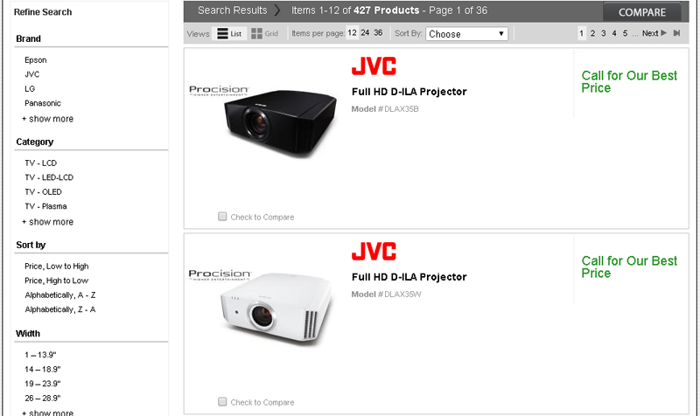

- Product Details page
==================
User will be able to enter the details of product

- Request a price page details
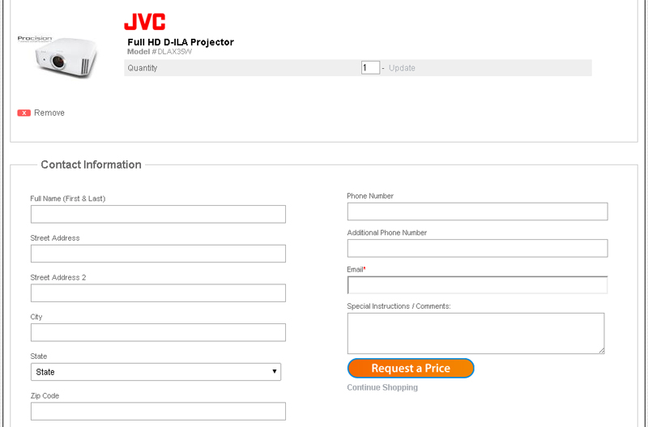
After submit the request details, system automatically send mail to admin.
- Services Offered
================

All the service details with contact information. Content will be managed from admin section.

- Photo gallery
===========
Categories wise photo gallery manage from admin section.
- Contact Us
==========
Office address with Google map. Contact form with name, email, phone number and message.

Admin Section
===================
- Login
- Change password
- Manage category
- Category wise product upload option
- Manage product
- Manage user request
- Manage service
- Manage Photo gallery

Our Responsibility: Requirement analysis, design, development, testing and client server deployment.
Client Responsibility: Domain, Hosting server, Website content, Video and paid image (If necessary).

Deliverables:
- Project document
- Design
- Coding
- Client server upload

Technical Requirements:
The following technology shall be adopted for the software application:

Architecture | MVC
Framework | CI
Language / Technology | PHP, JAVA SCRIPT, AJAX, XML.
Database | MYSQL

The software application shall be hosted in the web-server and shall be accessed through any desktop with browser.

Details | Time (Days) | Cost
Design and Development of all the module | 15 days | 39000/=RsS

